**ENSF 462 Lab 05 Report Completed by: Dominic Choi**

**UCID: 30109955**

|  |
| --- |
| router.py |
| import socket  import threading  import time  import sys  import json  def load_config(filename):      with open(filename, "r") as file:          lines = file.readlines()          node_count = int(lines[0].strip())          neighbors = []          for line in lines[1:]:              parts = line.strip().split()              if len(parts) == 4:                  neighbors.append({                          "label": parts[0],                          "id": int(parts[1]),                          "cost": int(parts[2]),                          "port": int(parts[3]),                      })                else:                  if line.strip():  # if line is empty or spaces                      print(f"Ignoring line: {line.strip()}")          return node_count, neighbors  def dijkstra(graph, source):      distance = {node: float('inf') for node in range(len(graph))}      previous = {node: None for node in range(len(graph))}      distance[source] = 0      unvisited = set(range(len(graph)))      while unvisited:          current_node = min(unvisited, key=lambda node: distance[node])          unvisited.remove(current_node)          for neighbor_info in graph[current_node]:              neighbor, cost = neighbor_info["id"], neighbor_info["cost"]              temp_value = distance[current_node] + cost              if temp_value < distance[neighbor]:                  distance[neighbor] = temp_value                  previous[neighbor] = current_node      return distance, previous  def send_udp(message, host, port):      with socket.socket(socket.AF_INET, socket.SOCK_DGRAM) as s:          s.sendto(message.encode(), (host, port))  def receive_udp(port):      with socket.socket(socket.AF_INET, socket.SOCK_DGRAM) as s:          s.bind(("", port))          message, _ = s.recvfrom(1024)      return message.decode()  def send_link_state(router_id, neighbors):      while True:          message = json.dumps({"id": router_id, "neighbors": neighbors})          for neighbor in neighbors:              send_udp(message, "localhost", neighbor["port"])          time.sleep(1)  def receive_and_broadcast_link_state(port, neighbors, link_state):      while True:          message = receive_udp(port)          data = json.loads(message)          link_state[data["id"]] = data["neighbors"]          for neighbor in neighbors:              send_udp(message, "localhost", neighbor["port"])  def print_routing_table(router_id, distance, previous, node_count):      router_label = chr(router_id + ord("A"))      # Print Dijkstra      print("------------------------------------")      print("DestID Dist PrevID")      for destination in range(node_count):          if destination == router_id: #if self, distance = 0              distance[destination] = 0              prev_node_id = router_id          else:              prev_node_id = (previous[destination]                              if previous[destination] is not None                              else "-")            print(f"{destination}      {distance[destination]}    {prev_node_id}")      # Forwarding table      print(f"\nThe forwarding table in {router_label} is printed as follows:")      print("DestID NextLabel")        for destination in range(node_count):          if destination != router_id:              next_hop = previous[destination]              if next_hop == router_id: # if direct connection                  next_hop_label = chr(destination + ord("A"))              else:                  while (previous[next_hop] is not None                         and previous[next_hop] != router_id):                        next_hop = previous[next_hop]                  next_hop_label = (chr(next_hop + ord("A"))                                    if next_hop is not None else "None")              print(f"{destination}      {next_hop_label}")      print("------------------------------------")  def main(router_id, router_port, config_file):      node_count, neighbors = load_config(config_file)      link_state = {router_id: neighbors}  # Initialize with self neighbors      # Threads for each component      send_thread = threading.Thread(          target=send_link_state, args=(router_id, neighbors))        receive_thread = threading.Thread(          target=receive_and_broadcast_link_state,          args=(router_port, neighbors, link_state))      send_thread.start()      receive_thread.start()      while True:          if len(link_state) == node_count:              distance, previous = dijkstra(link_state, router_id)              print_routing_table(router_id, distance, previous, node_count)          time.sleep(10)  if __name__ == "__main__":      if len(sys.argv) != 4:          print("Usage: python Router.py <router_id> <router_port> <config_file>")          sys.exit(1)      router_id = int(sys.argv[1])      router_port = int(sys.argv[2])      config_file = sys.argv[3]      main(router_id, router_port, config_file) |

Output: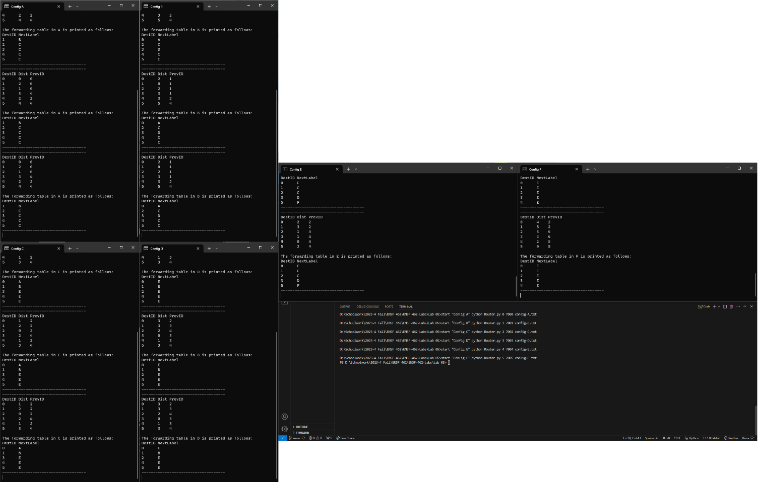

Better View of Screenshot:  
